Can You Guess Which Plant I Am?

Clues

This is what I look like:

1.

2.

This is where and how I grow:

3.

4.

Some other interesting facts:

5.

6.

Lift this paper for the answer.

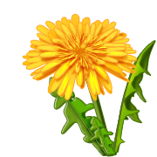

The name of this plant is the .

I found information for this report in .

By Third Grade Student

